14.

C program to write in a file

# include <stdio.h>

# include <string.h>

void main( )

{ FILE *fp ;

char data[50];

printf( "Opening the file test.c in write mode" ) ;

fp = fopen("test.txt", "w") ;

if ( fp == NULL )

{

printf( "Could not open file test.txt" ) ;

} printf( "\n Enter some text from keyboard to write in the file test.txt" ) ; while ( strlen ( gets( data ) ) > 0 )

{ fputs(data, fp) ;

fputs("\n", fp) ;

} printf("Closing the file test.txt") ;

fclose(fp) ;

}

OUTPUT:

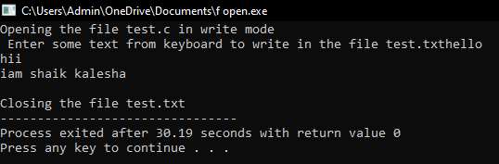

2.C program to read file

# include <stdio.h>

void main( )

{ FILE *fp ;

char data[50] ;

printf( "Opening the file test.txt in read mode" ) ;

fp = fopen( "test.txt", "r" ) ;

if ( fp == NULL )

{ printf( "Could not open file test.txt" ) ;

} printf( "Reading the file test.txt" ) ;

while( fgets ( data, 50, fp ) != NULL )

printf( "%s" , data ) ;

printf("Closing the file test.txt") ;

fclose(fp) ;

}

OUTPUT:

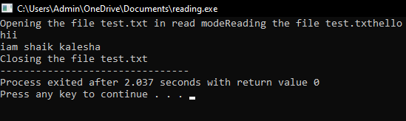

3.C program to reverse a file

#include <stdio.h>

void main()

{

FILE *fp;

char ch;

int i,pos;

fp=fopen("test.txt","r");

if(fp==NULL)

{

printf("file doesnot exist \n");

}

fseek(fp,0,SEEK_END);

pos=ftell(fp);

i=0;

while(i<pos)

{

i++;

fseek(fp,-i,SEEK_END);

ch=fgetc(fp);

printf("%c",ch);

}

}

OUTPUT:

